PROJECT 1
Name: Ayodeji Idowu
Role: Data Analyst Intern
TASK: DATA CLEANING AND PREPARATION
The messy datasets contain sales records with 14 columns and 1,200 rows. Out of the 1200 rows, there are 309 blanks in the CouponCode column. The objective is to perform data cleaning and preparation for further analysis. The task was accomplished using Excel and Power Query.
Step 1 – Download and Open with Power Query
- Download the Dataset for the DecodeLab Google Drive (data source)
- Open the downloaded dataset using MS Excel (raw dataset)
- Open another worksheet, and use Get New Data to open the dataset with Power Query in Excel.
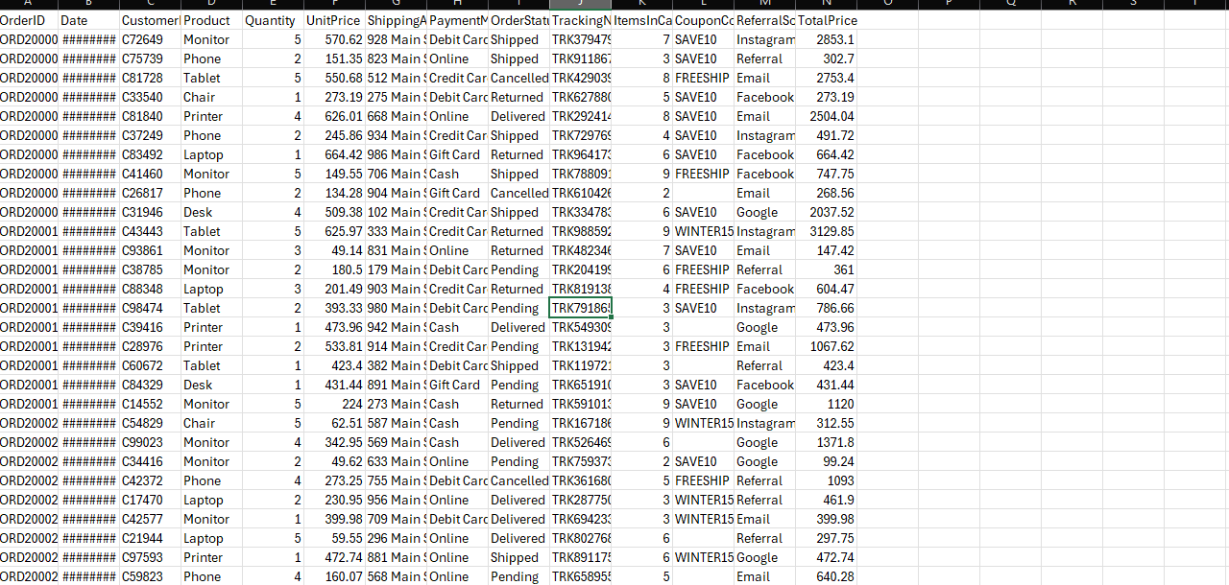
Step 2 – Identifying Missing Data
- I profile each column to check for missing or blank data using the Power Query quality bar.
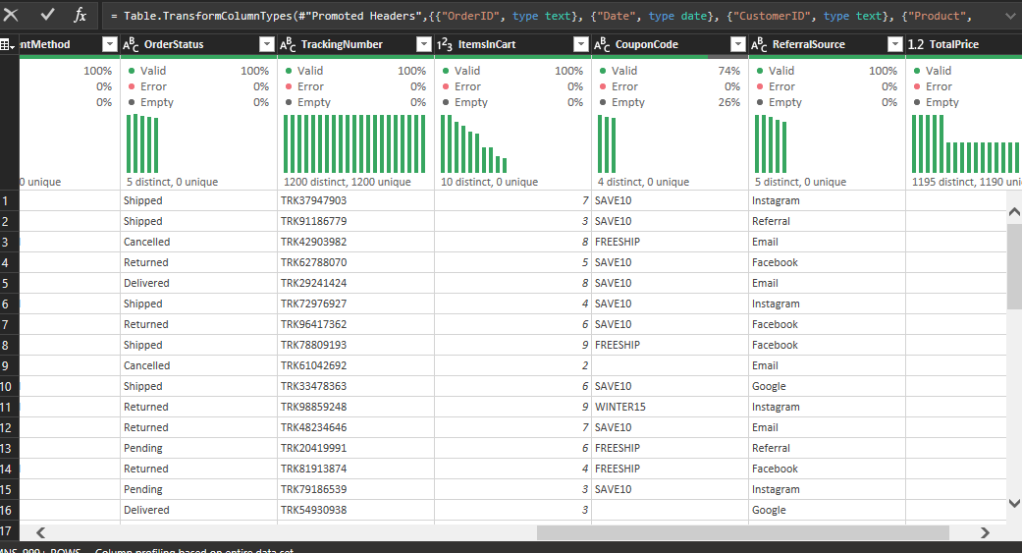

- The CouponCode column has 26% empty rows, which is 309 nulls.
- To fix this missing data, I replace blanks with “NO COUPON” which the following steps
- Right-click the CouponCode column header
- Click Replace Values
- In Value to Find — leave it blank (or type null)
- In Replace With — type No Coupon
- Click OK
Step 3 – Removing Duplicates
- Select all columns: click the first column header → hold Shift → click the last column header
- Go to Home tab > Remove Rows > Remove Duplicates
- The row count stays at 1,200 — confirming no duplicates existed
Step 4 – Fixing the Columns Data type
- OrderID Text (ABC)
- Date Date format
- CustomerID Text (ABC)
- Product Text
- Quantity Whole Number
- Unit Price $ Currency
- Total Price $ Currency
Step 5 – Clean and Trim whitespaces from Text Columns
- Hold Ctrl and click to select all these columns:
- OrderID, CustomerID, Product, ShippingAddress, PaymentMethod, OrderStatus, TrackingNumber, CouponCode, ReferralSource
- Transform tab > Format > Trim
- Transform tab > Format > Clean
Step 6 – Apply Standardise Text Case
Apply uppercase to categorical columns:
- Hold Ctrl and select: Product, PaymentMethod, and OrderStatus.
- Transform tab > Format > Capitalise Each Word
Step 7 - Fix the Date Column
- Fix the Date column to complied with ISO 8601
- I tried this using the Localise date custom, which does not comply with the standard I need.
- After loading the table in Excel, I use date custom
- Once loaded into Excel, select the Date column
- Press Ctrl + 1 → go to Custom
- In the Format box, type: yyyy-mm-dd
- Click OK
Step 8 – Load Cleaned Data Into Ms Excel
- Go to Home tab > Close & Load.
- Click OK
- A new worksheet opens with the cleaned dataset.
- Rename it to Cleaned Dataset
